**ABSTRACT**

GoBikes! is a web application where users enter into it and purchase a product (i.e. bike) through online itself instead of going to the showrooms which are especially far from the location of his/her stay. The software has the facility to give a unique id for every user who registers into the application and stores their details in the database automatically. The data can be retrieved easily. The interface is very user-friendly. The data are well protected for personal use and makes the data processing very fast. The admin is responsible for adding the products into the application to make them available for users to purchase. The users can also search the products available online through shop by category making them much more easier to purchase.

# HARDWARE REQUIREMENTS:

# Processor - Pentium IV

Speed - 2.4 GHz

RAM - 2GB (min)

Hard Disk - 20 GB

# SOFTWARE REQUIREMENTS:

Operating System - Windows XP/7/10

Browser - Mozilla Firefox, Chrome

Front End - HTML, CSS, BOOTSTRAP, SPRING

Back end - H2 database

GoBikes!

Home page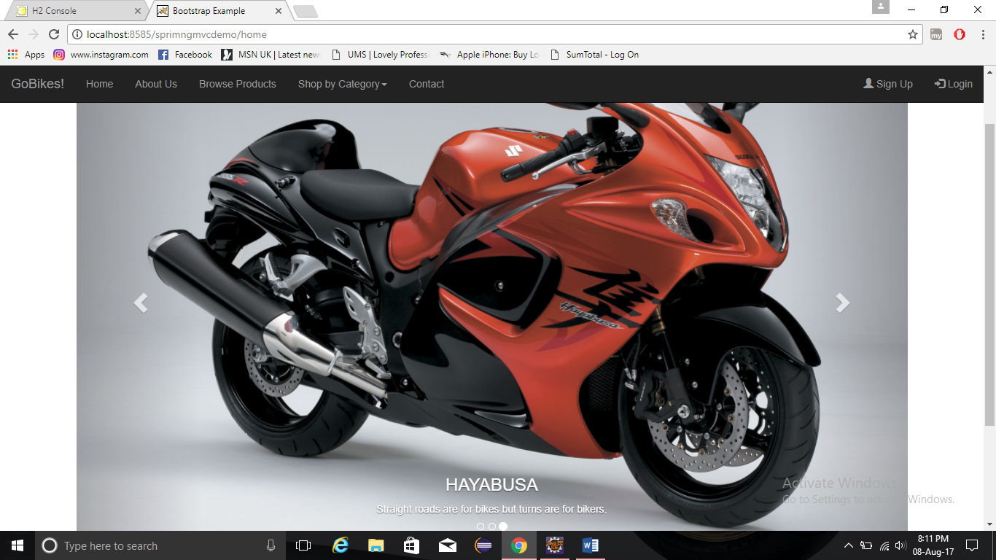

This is the home page of GoBikes! web application.

About Us Page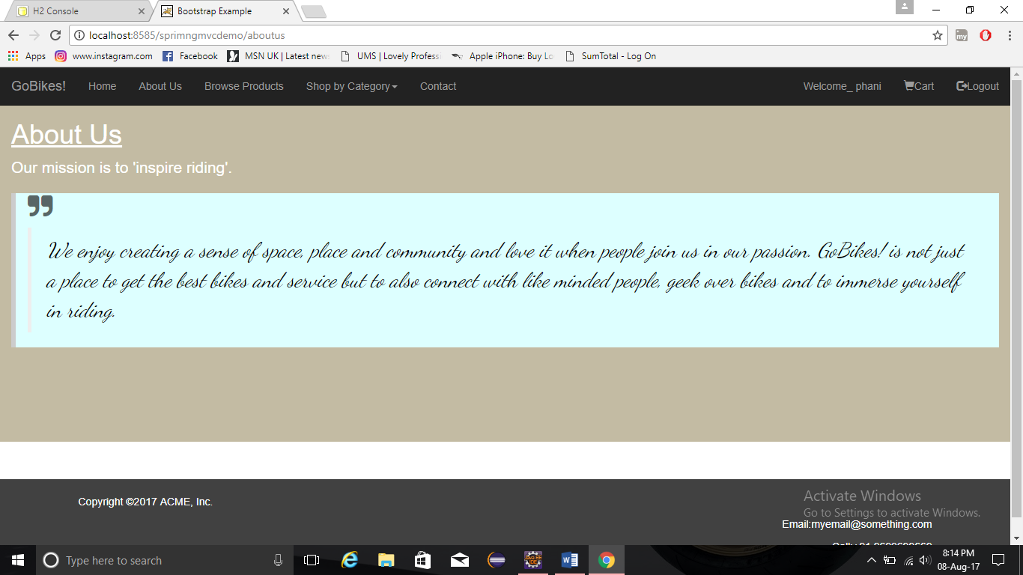

This is the about us page of GoBikes!

Contact Page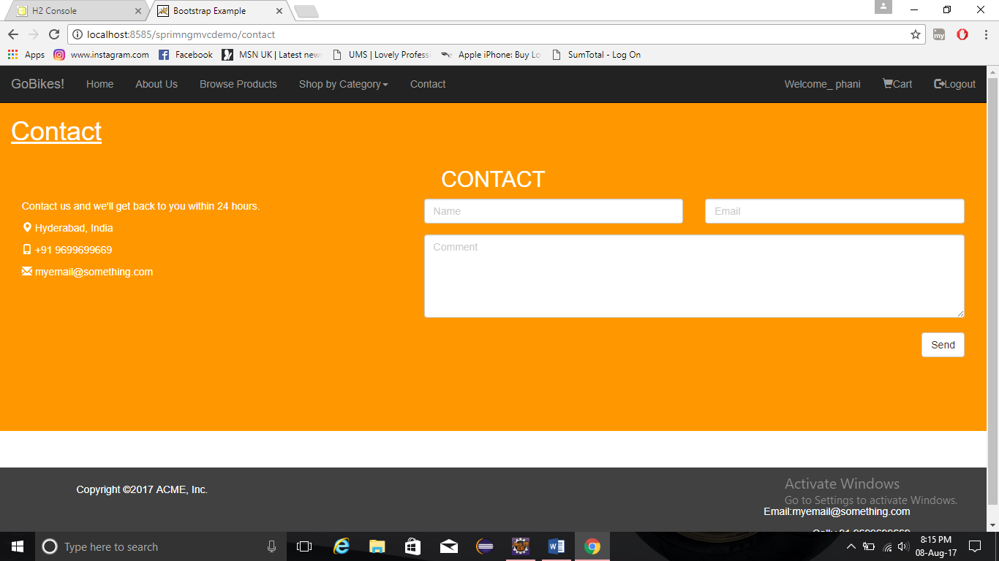

This is the contact page of Gobikes!

Sign Up Page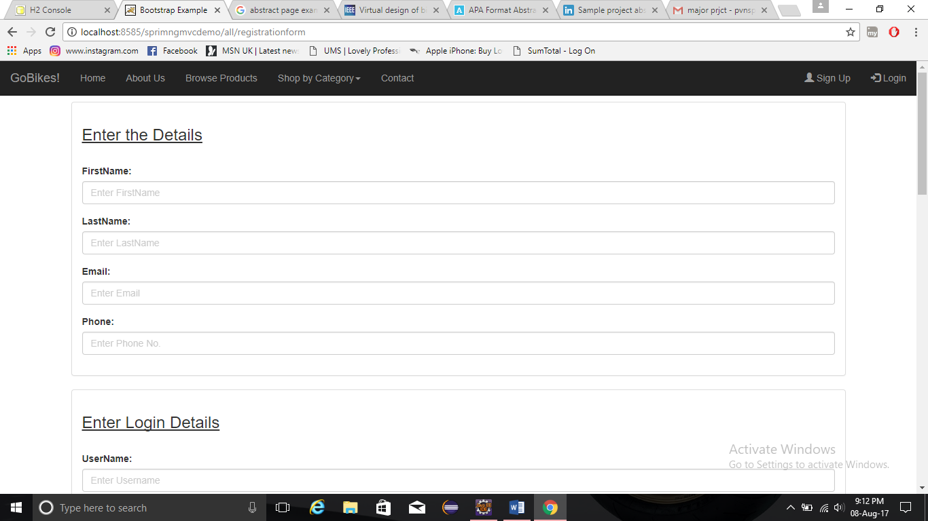

This is the page where user has to register with his detailed information to log into the application.

Login Page (as User)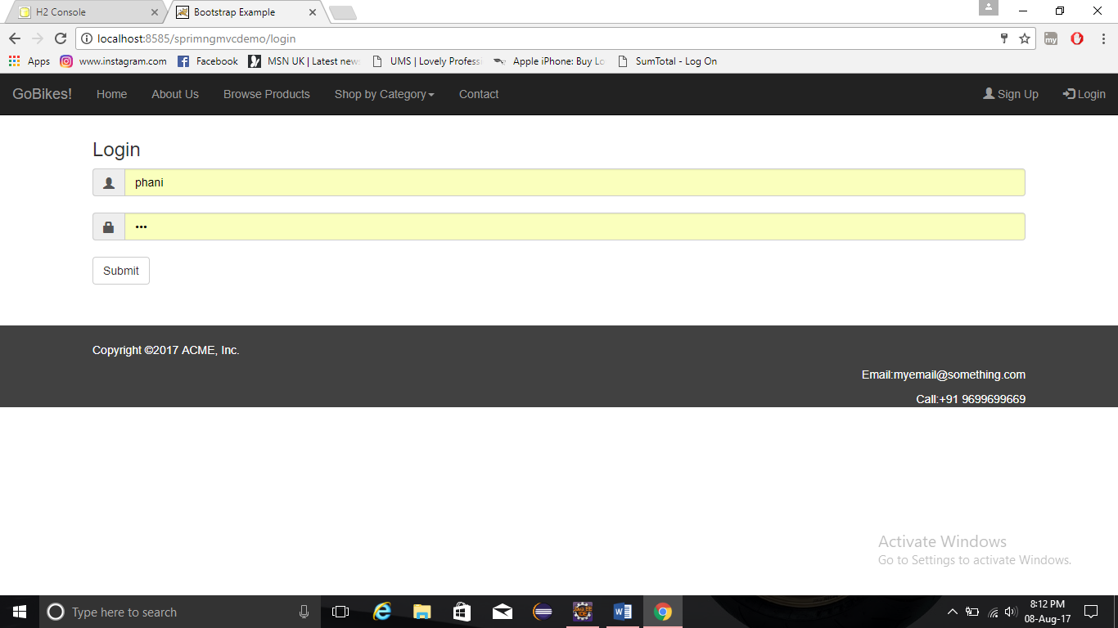

This is the login page of user where user enters into the application as customer.

Browse Products Page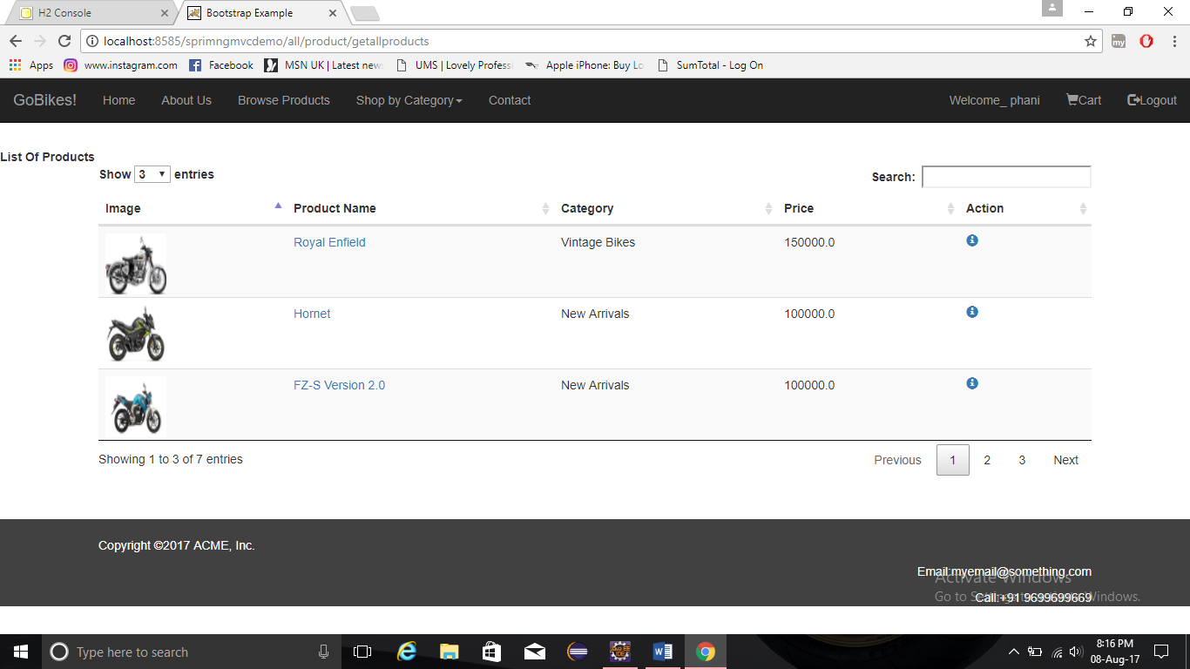

This is the page which gives list of products available in the application for purchase.

Shop By Category Page (i.e. New Arrivals)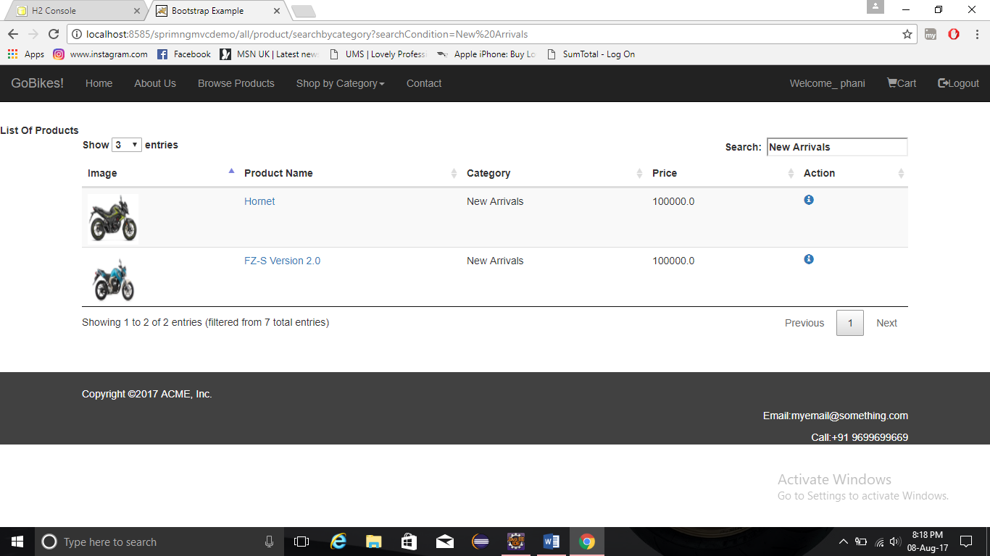

This is the page user can shop the available products based on the categories.

Product Details Page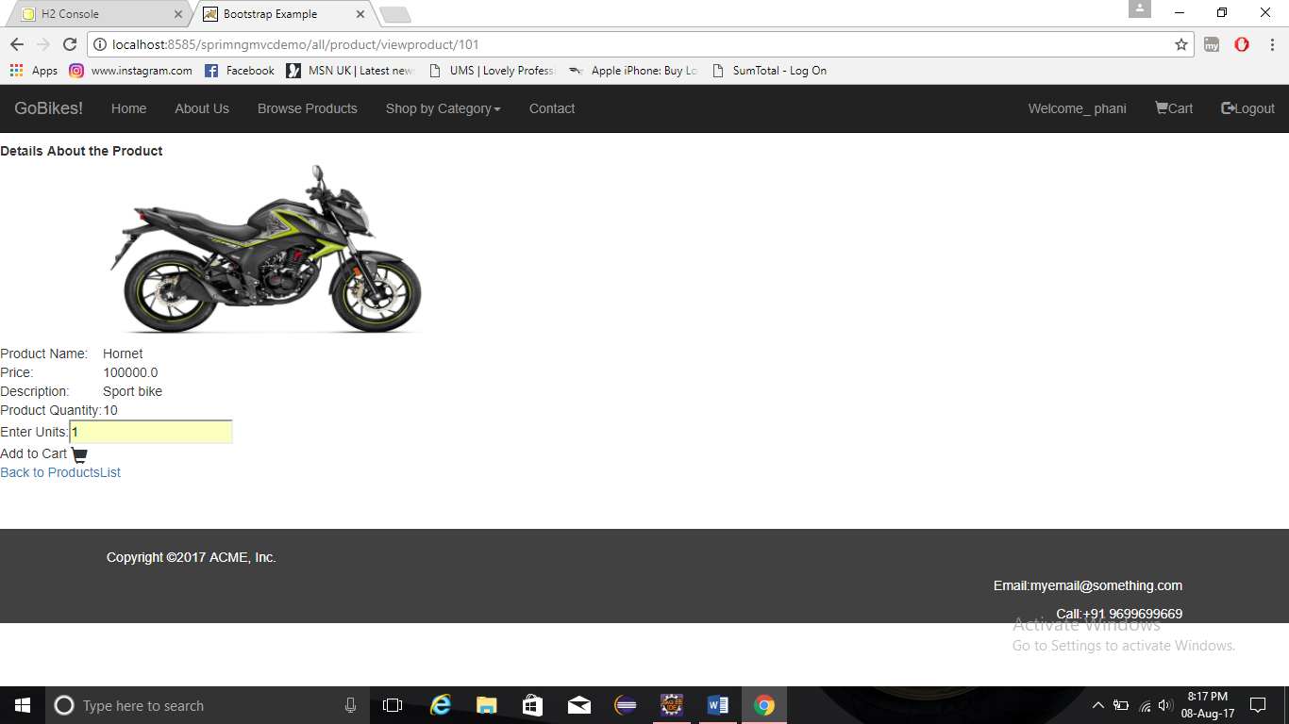

This is the page which gives detail description of that particular selected product.

Cart Page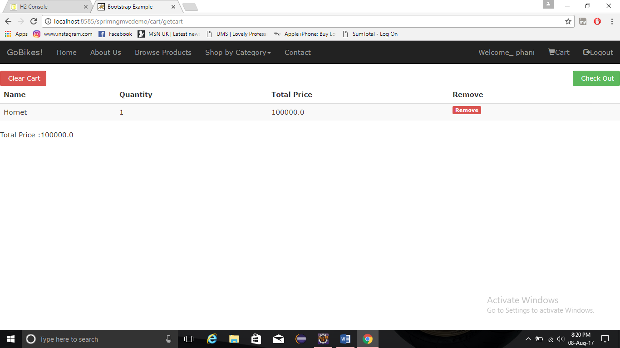

This is the page where user gets redirected after adding a product into the cart.

Checkout Page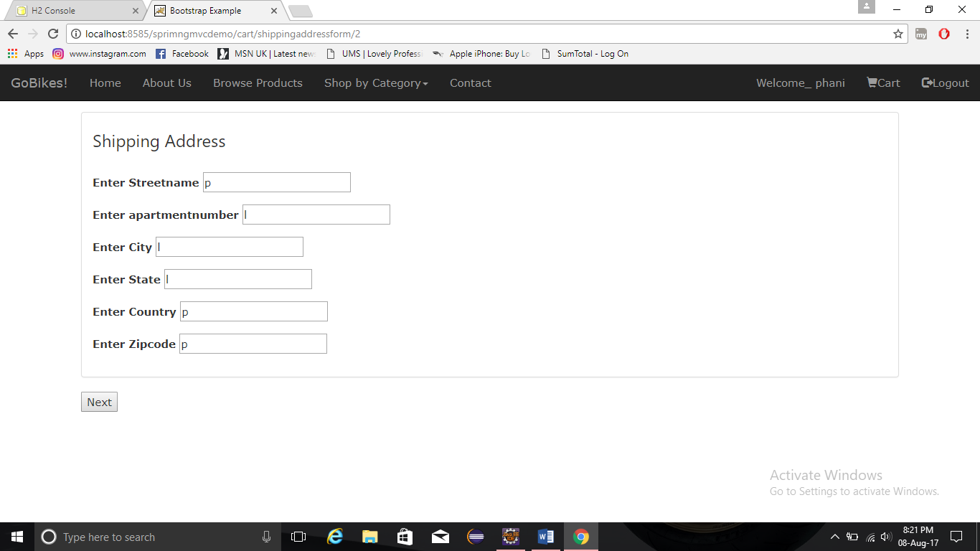

This is the checkout page where user has to enter the shipping address to purchase the product in the car.

Receipt Page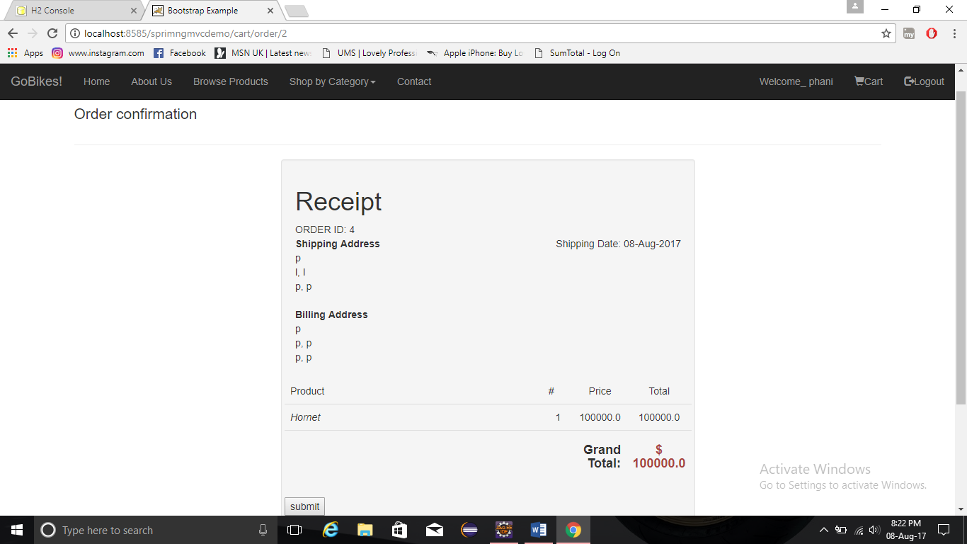

This is the receipt of purchased products.

Thankyou Page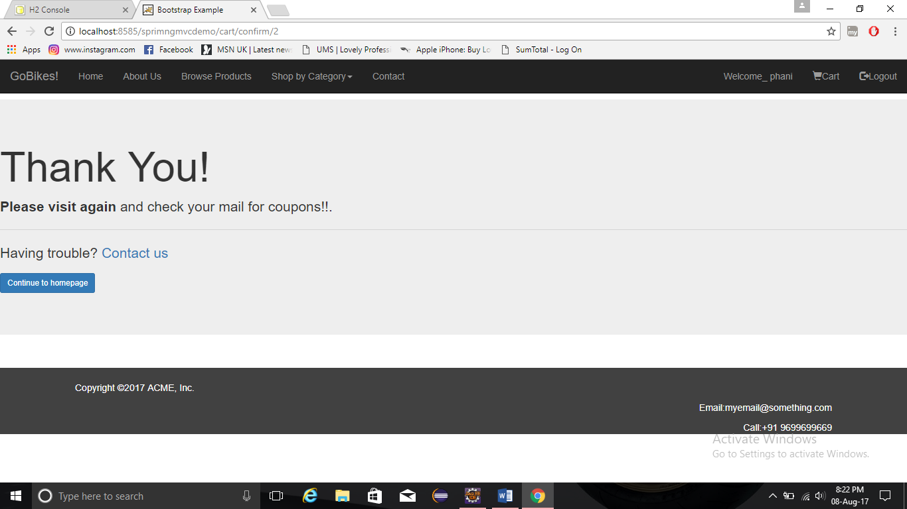

This is the last page after successfully purchasing a product by the user.

Login Page (as Admin)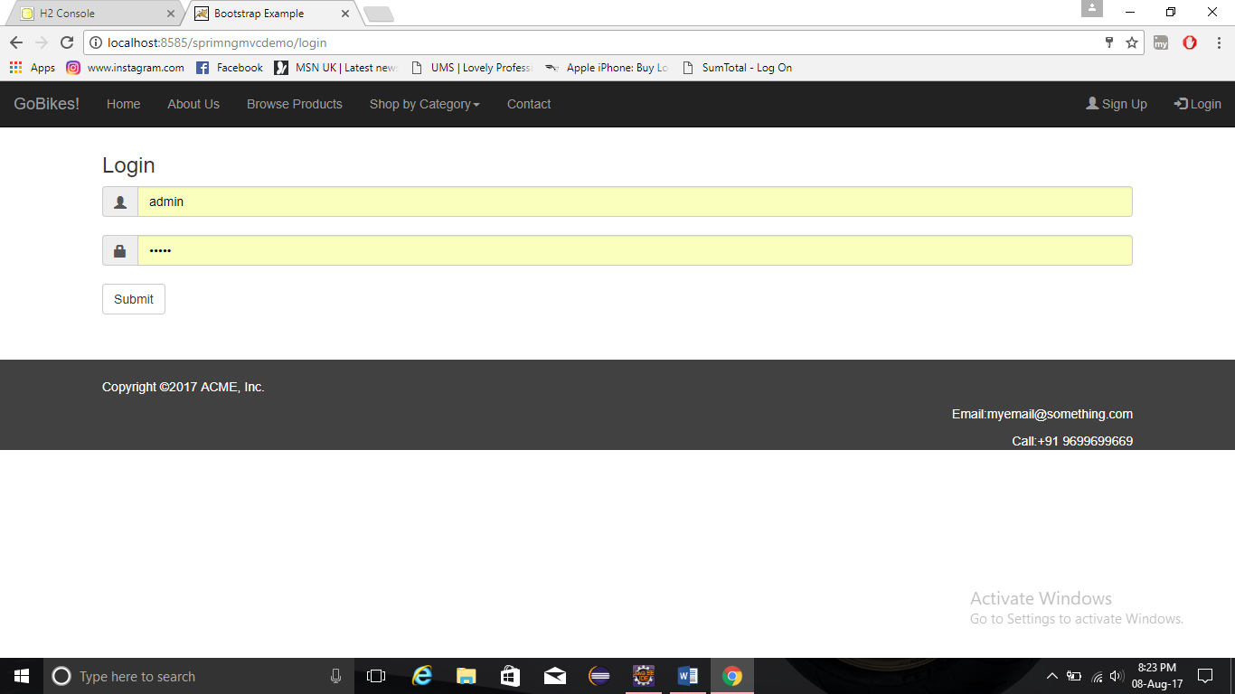

This the login page where admin is trying to log into the application.

Add Product Page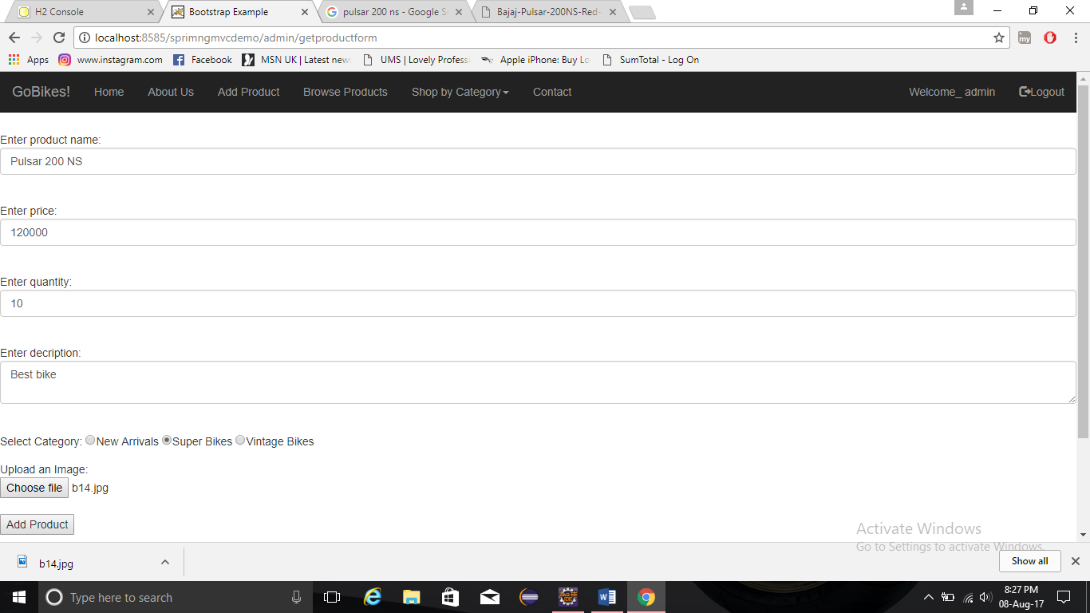

This is the page where admin can add the products into the application available for users.

Edit Page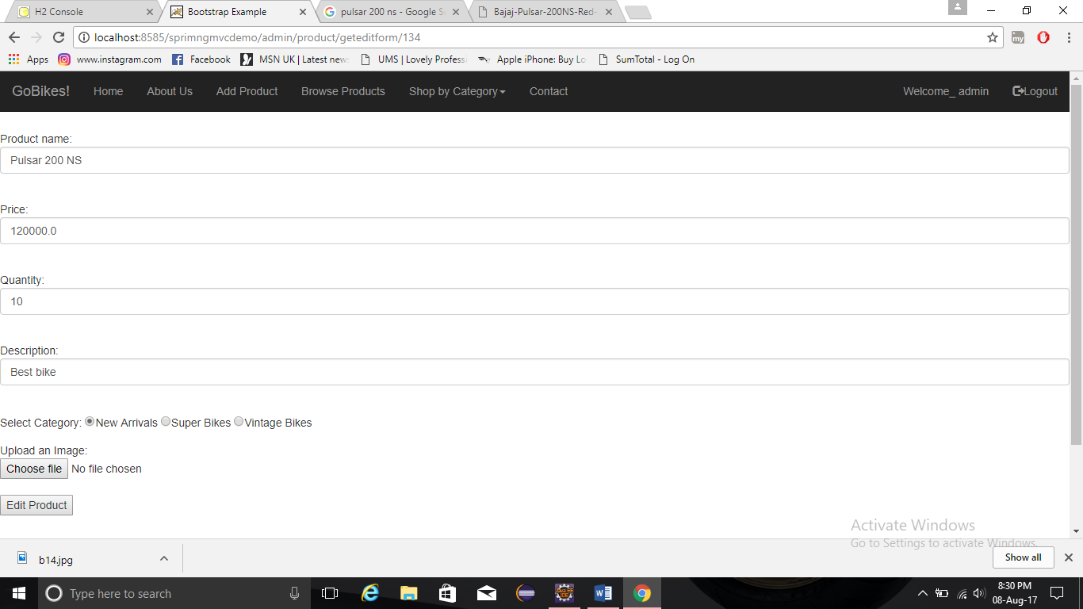

This is the page where admin can edit the already added product in the application.